Assignment 5 - Building an Image using DockerFile

Step1

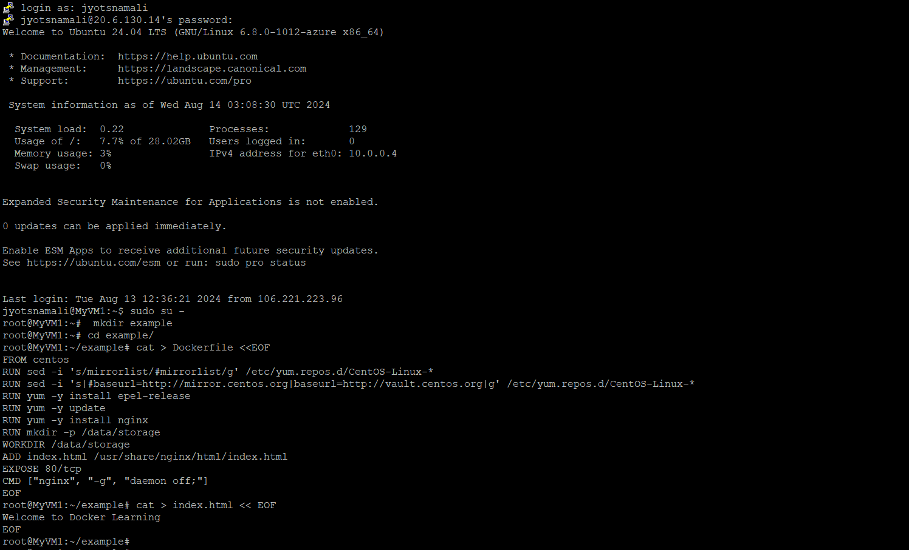

Step2

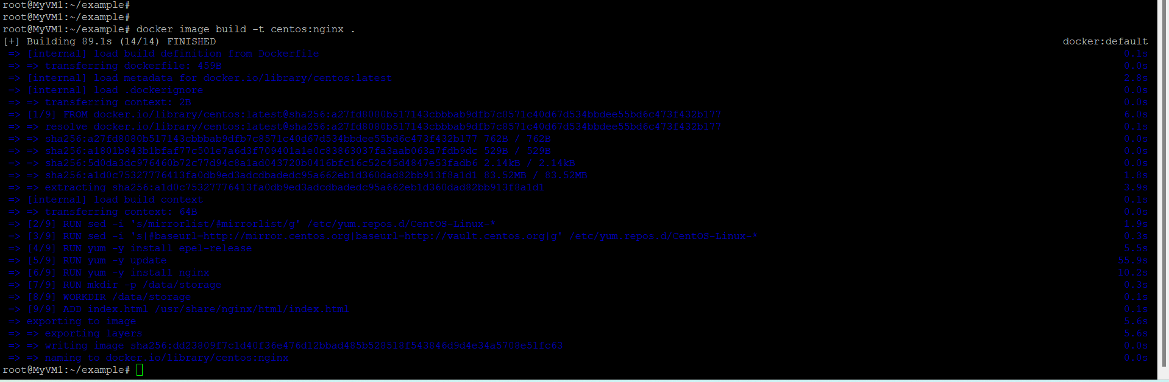

Step3

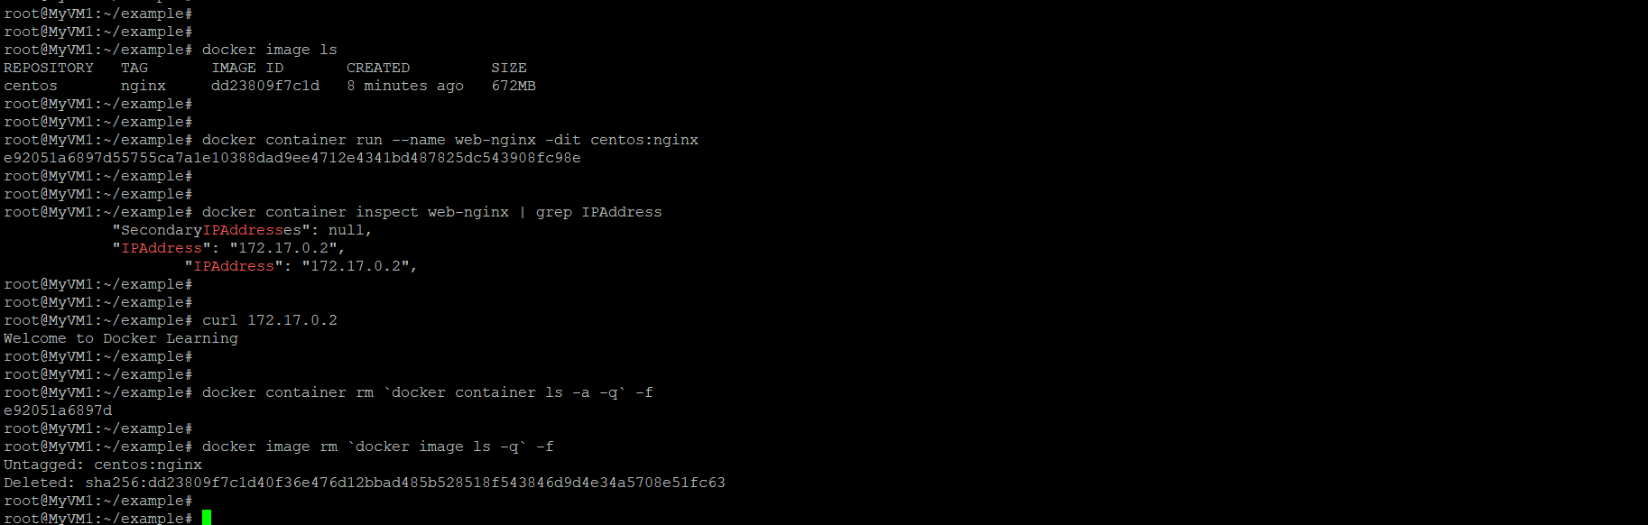

Step 4

